member
of the year

presented to
May 5, 2021
AAF Club
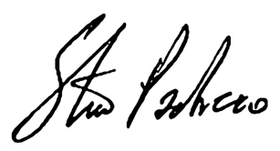
First Name Last Name

Steve Pacheco
AAF National President & CEO

[[Signature image]]

[[Name of Club AAF Leader]]

[[Date here]]

Date

in recognition to their hard work and service to
AAF Club Name
a professional chartered club of the American Advertising Federation

